**PROJECT MANAGEMENT PLAN**

**FOR THE**

**CINEMA MANAGEMENT SYSTEM**

**CMS**

**11/6/2020**

Team Name: 14

Team Member 1: Basel Marawan 186279

Team Member 2: Mostafa Ahmed 188827

Team Member 3: Ziad Al-Naggar 189714

Team Member 4: Mohamed Ahmed 185908

**[[CINEMA MANAGEMENT SYSTEM, CMS1]]**

|  | CINEMA MANAGEMENT SYSTEM PMP  CMS  11/6/2020 | |
| --- | --- | --- |
|  |  | |
|  |  | |
|  | |

Table of Contents

**SECTION 1. OVERVIEW 3**

1.1 PROJECT SUMMARY 3

1.1.1 SCOPE & OBJECTIVES 3

1.1.2 ASSUMPTIONS & CONSTRAINTS**…………………………………………………………………………………….……………….….**4

1.1.3 PROJECT DELIVERABLES**……………………………………………………………………………………………………………………**4

**SECTION 2. PROJECT ORGANISATION 5**

2.1 PROJECT ROLES & RESPONSIBILITIES 5

2.1.1 ORGANISATIONAL STRUCTURE 6

2.1.2 ROLES & RESPONSIBILITIES**…………………………………………………………………………………………………………….5**

**SECTION 3. MANAGEMENT PROCESS…………………………………………………………………………5**

**3.1 START-UP………………………………………………………………………………………………5**

3.1.1 ESTIMATION**……………………………………………………………………………………….5**

3.2 WORK PLANNING**……………………………………………………………………………………21**

3.2.1 WORK ACTIVITIES**……………………………………………………………………………….21**

**SECTION 4. TECHNICAL PROCESS…………………………………………………………………………..23**

**4.1 METHODS, TOOLS AND TECHNIQUES…………………………………………………………23**

4.3 PROJECT INFRASTRUCTURE**………………………………………………………………………25**

**SECTION 5. Management Process……………………………………………………………………...………..28**

**5.2 WORK PLANNING………………………………………………………………………………...28**

5.2.2 WORK ACTIVITIES**…………………………………………………………………………….28**

**5.4 RISK MANAGEMENT………………………………………………………………………….....**3**6**

ii

CINEMA MANAGEMENT SYSTEM PMP

CMS

11/6/2020

**SECTION 1. OVERVIEW**

* 1. **PROJECT SUMMARY**

The idea of this project stems from the inefficient way some companies manage their data. The software project will assist companies like IMAX, AMC and many others in handling critical theatre and business data. It is expected to dramatically increase workplace transaction smoothness and minimize interaction between staff and attendees.

**1.1.1 Scope, and Objectives**

The purpose of this project is to develop a self-sufficient software management system that will assist large theatre companies in managing individual theatres (cinemas) through creating a clear and concise way of viewing attendee information as well as managing showrooms and employee data. It will allow the client to modify, add or merge theatre data which consists of movies, advertisements, expenses, employees, attendees and operating fees. The project also aims to facilitate the process of filling out showrooms and mapping attendees without the help of ushers or assisting staff through detailed maps that would be present for every attendee.

**1.1.2 Assumptions and Constraints**

Assumptions:

* The Waterfall methodology to be used.
* Each project phase shall obligate to its time.
* The Stakeholders to provide the funding at the start of the project.
* Stakeholders will provide more funding for the project if current budget is exceeded.
* Qualified and Experienced team members to work on the project.
* All Equipment is readily available on time and is in good shape.
* Teams who worked on the project to be available after the project release to fix bugs and provide improvements if needed.
* Beta testers shall provide a full review.
* Detailed documentation will be provided in the two main languages of the Client’s country.

3

Constraints:

* The Software is to be delivered in 3 months.
* The Software is to be running smoothly and all prior functionalities to work as intended to without errors.
* The project to be funded with 1000 US Dollars.
* A Satisfying sustainability to be met.
* Coping with the project plan and limitations.
* The Software is to gain Customer Satisfaction.

**1.1.3** **Project Deliverables**

The project deliverable is to be a software product and is to be delivered alongside detailed documentation through both a USB driver and through mail as a backup. The software product is to be completed in 12 weeks and is to be delivered to a location of the client’s choosing.

| **Inputs** | **Process** | **Outputs** | **Due Dates** |
| --- | --- | --- | --- |
| Business Plan | Initiating | Project Chart | One Week |
| Project Chart and Improvements made | Planning | Project Plan: Deliverables Diagram – Issues and Risks – Contracts – Schedules - Costs | Three Weeks |
| Project Plan and Chart | Execution | Performance Reports – Issue and Changes Reports – Project Progress Logs – Deliverables (Product - Software) | Three Weeks |
| Reports and Deliverables | Ending | Product Acceptance – Final Reports – Project Documents | Two Weeks |

4

CINEMA MANAGEMENT SYSTEM PMP

CMS

11/6/2020

**SECTION 2. PROJECT ORGANIZATION**

**2.1** **PROJECT ROLES AND RESPONSIBILITIES**

**2.1.1 Organizational Structure**

-The project splits into 4 major phases and for each phase there is a manager/team leader:

(1) Analysis Phase

(2) Design Phase

(3) Implementation Phase

(4) Testing Phase

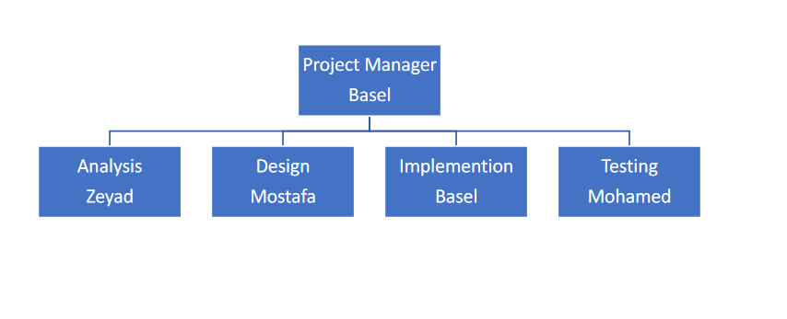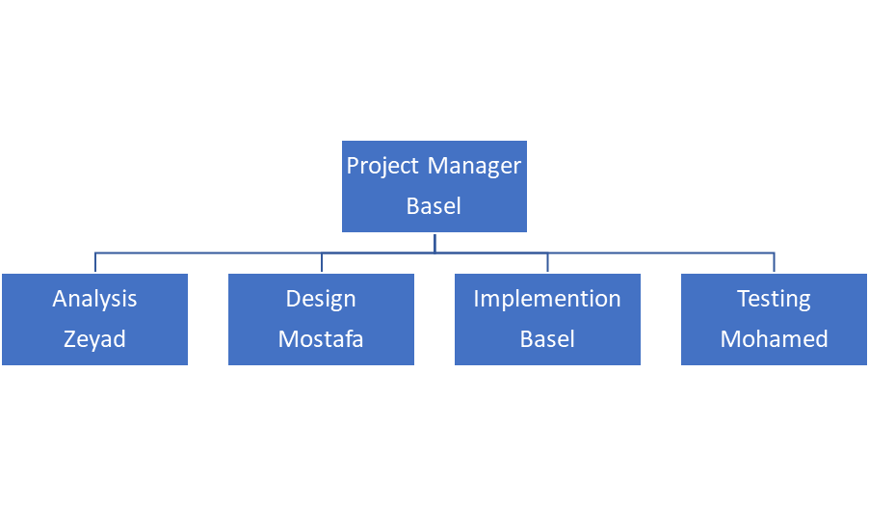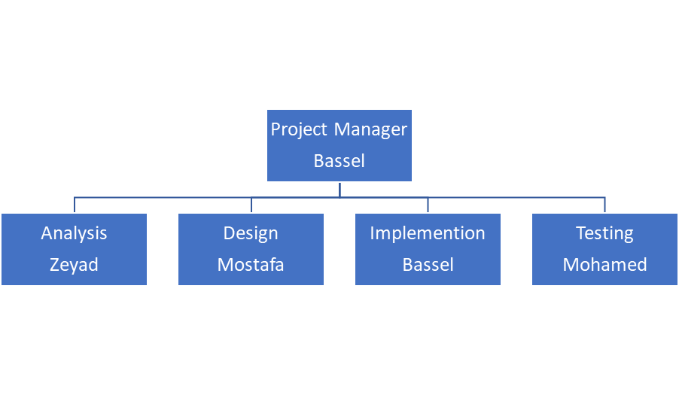

5

**2.1.2 Roles & Responsibilities**

**-Project Manager**: He / She plays the major role in the project and is responsible for its successful completion. The manager’s job is to ensure that the project proceeds within the scheduled time and the pre-decided budget, while achieving its objectives. Project managers make sure that projects are given sufficient resources, while managing relationships with other team leaders, team members and stakeholders.

**-Analysis Manger :** Along with a team of analysts, he / she is responsible for creating reports to decide the system constraints and requirements to ensure the flexibility, speed and reliability explicitly of the system, and meet with the system stakeholders to deicide the functional requirements and quires of the system that they will be using when the system is fully operational. The last part of the analysis phase is writing all the possible scenarios for using the system by the stakeholders and determine the actors in each scenario, description, priority and the feedback that the system should provide after the user does certain steps.

**-Design Manager:** Splits the design tasks of design between the team members, which include the context diagram, use case diagram and activity diagram. Each diagram represents a different method of explanation of the interaction between the system and users, while justifying the roles and permissions given to each user and the functionality given to each user.

**-Implementation Manager** : In the implementation phase, the developers are required to create a database schema and class diagram and the relate them to each other based on the given data and the requirements of the system, then start implementing them using the needed tools like SQL Server and Net Beans.

**-Testing Manager:** Assesses the application to make sure it fulfills the design specifications and satisfies the client needs. Test the programs or software functions using acritical data (test data) to detect errors or things that do not work the way they are supposed to.

**SECTION 3. MANAGEMENT PROCESS**

**3.1 Start-up**

**3.1.1 Estimation**

**Size Estimation:**

**Function Payment: (basel186279)**

It is assumed that the customer uses a credit card for payment.

The customer proceeds to the payment screen, receiving a detailed invoice of purchased items in the theatre. The customer confirms invoice items and is presented with the payment details section, where the credit card number is entered, automatically determining the payment network.

After entering all required information (Cardholder Name, Address, CVC, and Expiration Date.

The bank then validates the submitted information, prompting the customer to confirm the payment if the validation process is successful. The bank saves a detailed copy of each transaction’s details and various other processes that occur on the bank’s side of the system. This is mirrored on the Cinema’s Management system, as a detailed order invoice is logged and a Success message appears to the customer, informing him of the transaction’s number in case it is needed in the future, sending the customer an SMS or an email message with the invoice.

1. **Count of Components**

External Input Types (EIs): 7

1. Network Type.
2. Cardholder Name.
3. Card Number.
4. Expiration Date.
5. CVC (or CCV).
6. Phone Number.
7. Address.

External Output Types (EOs): 3

1. Payment confirmation message.
2. Confirmation SMS.
3. Confirmation E-Mail.

External Inquiry Types (EQs): 2

1. Bank transaction invoice.
2. Customer order information.

Logical Internal File Types (LIF): 2

1. Customers Table.
2. Transactions and Orders Table.

External Interface File Types (EIF): 1

1. Payment information table.

**Identify Datatypes, Record Types and Complexity.**

EI:

7 Datatypes: Network Name, Cardholder Name, Card Number, CVC (or CVV), Expiration Date, Phone Number, Address.

1 Record types: User Input.

(LOW COMPLEXITY)

EO:

3 Datatypes: SMS, email message, Payment Confirmation on-screen message.

2 Record types: email table, transaction table.

(LOW COMPLEXITY)

EQ:

10 Datatypes: Network Name, Cardholder Name, Card Number, CVC (or CVV), Expiration Date, Phone Number, Cost, Date of Transaction, Order Date, Address.

4 Record types: User Input, bank transaction invoice table, orders table, email table

(HIGH COMPLEXITY)

LIF:

11 Datatypes: Cardholder Name, Customer Name, Cost, Payment Network Name, Expiration Date, CVC (or CVV), Address, E-Mail Message, Order Date, Date of Transaction, Confirmation Message.

4 Record Types: email table, orders table, bank transaction invoice table, customers table.

(LOW COMPLEXITY)

EIF:

9 Datatypes: Payment Network Name, Cardholder Name, Card Number, Expiration Date, Address, CVV (or CVC), Phone Number, date of transaction, issuing bank.

2 Record Types: Orders table, bank transaction invoice table.

(LOW COMPLEXITY)

Size Estimation: (7* 3) + (3* 4) + (2* 6) + (2* 7) + (1* 5) = 64 FP

64 FP * 60 = 3840 LOC = 3.84 KLOC

**Function View Movie: (basel186279)**

The system can produce a detailed page that houses all available information about a movie that exists in the Management System’s database, including but not limited to: Name, Release Date, Average Rating, Genre, Synopsis, ID, Cast information and Related Works.

This information is displayed in a user-friendly fashion, also allowing the user to quickly edit movie information as well as submit feedback about incorrect information.

Related Works section filters movies, showing the first matches for the same director/main cast/genre on a different movie. The view movie screen also has the next screening date at the theatre, allowing the viewer to quickly extract the desired information simply by searching for the movie’s Name or ID.

1. **Count of Components**

External Input Types (EI): 4

1. Feedback Message
2. Username
3. Email address
4. Movie Information

External Output Types (EO): 1

1. Confirmation Message

External Inquiry Types (EQ): 1

1. Feedback Message

Logical Internal File Types (LIF): 3

1. Table of Movies
2. Table of Modifications
3. Table of Employees

External Interface File Types (EIF): 0

**Identify Datatypes, Record Types and Complexity.**

EI:

4 Datatypes: Feedback Message, Username, Email Address, Movie Information.

1 Record types: User Input

(LOW COMPLEXITY)

EO:

1 Datatype: Confirmation Message

1 Record Type: Modifications Table

(LOW COMPLEXITY)

EQ:

3 Datatypes: Feedback Message, Username, Email Address

2 Record Types: Modifications Table, Employees Table

(LOW COMPLEXITY)

LIF:

10 Datatypes: Name, Release Date, Average Rating, Genre, Synopsis, ID, Cast information, Feedback Message, Username, Email Address.

3 Return Types: Movie table, Employees table, Modifications Table

(LOW COMPLEXITY)

EIF:

0 Datatypes

0 Return Types

(LOW COMPLEXITY)

Size estimation: (4*3) + (1*4) + (1 *3) + (3*7) + (0* 5) = 40 FP

40 FP * 60 = 2400 LOC = 2.4 KLOC

**Effort Estimation:**

FOR FUNCTION PAYMENT: (USING COCOMO81) (basel186279)

Effort = C (Size)k

C = 2.4, K = 1.05

Effort = 2.4(3.84)1.05 = 9.857323 Person-Months

FOR FUNCTION VIEW MOVIE: USING COCOMO II (basel186279)

**Exponent Driver Ratings:**

**PREC: HIGH (2.48):**

**There is precedence for functions similar to view movie, since it mainly prints out information for the user. It also allows the user to submit feedback.**

**FLEX: NOMINAL (3.04):**

**This function is less flexible than average, since it does not have room for modifications, it has a fairly simple purpose.**

**RESL: LOW (5.65):**

**The function’s requirements are concise and obvious. There is little room for change, and even lesser cause.**

**TEAM: HIGH (1.10):**

**The team is very cohesive, living next to each other and directly communicating throughout the work day.**

**PMAT: HIGH (1.56):**

**The team is very well organized and the project itself is well structured.**

**View movie function handling is very good.**

**Sum= (2.48+3.04+5.65+1.10+1.56) = 13.83**

**EFFORT MODIFIERS:**

| **Effort Modifier** | **Rating** | **Multiplier** |
| --- | --- | --- |
| **RELY** | **Very High** | **1.26** |
| **DATA** | **Nominal** | **1.00** |
| **DOCU** | **Nominal** | **1.00** |
| **CPLX** | **High** | **1.17** |
| **STOR** | **Very High** | **1.17** |
| **LEXP** | **Nominal** | **1.00** |
| **TOOL** | **High** | **0.90** |

**A = 2.94 (Constant), B = (0.91)**

**Scale factor: 0.91 + 0.01(13.83) = 1.0483**

**Effort multipliers: 1.5523326**

**Effort= Constant * (Size)sf  * Effort Multipliers**

**Effort = 2.94 * (2.4)1.0483 * 1.5523326 = 11.42635 Person-Months**

**ZIAD   
Assign Movie:**

When a staff member that is assigned to put movies in theatres’ schedule, he/she uses a functionality in the system called “Assign Movie”. While using this functionality the user will be asked to pick a movie from the available movies list, and he/she has to choose a theatre and the show type 2d or 3d. Then the user has to pick an available date and time for the show, the user may add more than one time for each date.

Each Show has movie id, theatre id, show type, assigned dates, assigned times, user id, edit date. A confirmation message is shown to the user when he wants to save the changes. When the changes are made, all the data along with the adjustment date and the user id will be saved in the database in the Show table, and message will appear to the user to inform him that the change are saved and asks him if he wants to add another date. So, each movie may be showed in more than one theatre, and a theatre can show more than one movie (Many-to-many relationship).

1. **Count of components**

External Input types (EI): 5

1. Movie ID
2. Theatre ID
3. Show type
4. Assigned Date
5. Assigned Times

External Outputs types (EO): 2

1. Confirmation message that asks the user if he wants to save or not.
2. Message asking the user if he wants to add another date.

External inquiry types (EQ): 1

1. Inset Movie Assignment into Database

Logical internal file types (LIF): 3

1. Show table
2. Movie table
3. Theatre table
4. User table

External interface file types (EIF): 0

1. **Identifying Datatypes, Record Types and Complexity:**

EI:

* 5 Datatypes: Movie ID, Theatre ID, Show Type, Date, Times
* 1 User input
* Low Complexity

EO:

* 1 Datatypes: Message of saved show status
* 1 Record types: Show Table
* Low Complexity

EQ:

* 7 Datatypes: Movie ID, Theatre ID, Show Type, Date, Times, User ID, Edit Date
* 1 Record types: Show Table
* Low Complexity

LIF:

* 7 Datatypes: Movie ID, Theatre ID, Show Type, Date, Times, User ID, Edit Date
* 4 Record types: Show Table, Theatre Table, Movie Table, User Table
* Low Complexity

EIF:

* 0 Datatypes:
* 0 Record types:
* Low Complexity

**Size Estimation**: (5*3) + (1*4) + (7*3) + (7*7) + (0*5) = 89 FP

89 FP * 60 = 5340 LOC = 5.34 KLO

**Effort Estimation:**

COCOMO 81

System type: Organic

So, C = 2.4 and K = 1.05



**Assign Job:**

The employee manger is responsible for assigning and reassigning employees to do a current job; so, when the employee manger assigns employees, he uses a functionality called “Assign Job” in which he chooses an employee for the employee list and assign a job to him and its locations like “Cashier No. 6” along with the start date and the duration of the assignment, and if the employee is already assigned to a job, his job and its remaining duration will be shown.

Each job assignment has user id, job title, start date, duration. When the manger clicks the save button, the data will be saved is the database in user table.

1. **Count of components**

External Input types (EI): 5

1. User ID
2. Job Title
3. Location
4. Start Date
5. Duration

External Outputs types (EO): 1

1. Confirmation message that asks the user if he wants to save or not.

External inquiry types (EQ): 1

1. Inset Job Assignment into Database

Logical internal file types (LIF): 1

1. User table

External interface file types (EIF): 0

1. **Identifying Datatypes, Record Types and Complexity:**

EI:

* 5 Datatypes: User ID, Job Title, Location, Start Date, Duration
* 1 User input
* Low Complexity

EO:

* 1 Datatypes: Message of saved Job Assignment status
* 1 Record types: User Table
* Low Complexity

EQ:

* 5 Datatypes: User ID, Job Title, Location, Start Date, Duration
* 1 Record types: User Table
* Low Complexity

LIF:

* 5 Datatypes: User ID, Job Title, Location, Start Date, Duration
* 1 Record types: User Table
* Low Complexity

EIF:

* 0 Datatypes:
* 0 Record types:
* Low Complexity

**Size Estimation**: (5*3) + (1*4) + (5*3) + (5*7) + (0*5) = 69 FP

69 FP * 60 = 4140 LOC = 4.14 KLO

**Effort Estimation:**

COCOMO II

Scale factor values:

| **Driver** | **Rating** | **Multiplier** |
| --- | --- | --- |
| **PREC** | Nominal | 3.72 |
| **FLEX** | High | 2.03 |
| **RESL** | Low | 5.65 |
| **TEAM** | Low | 4.38 |
| **PMAT** | V. High | 1.56 |

| **Driver** | **Comments** |
| --- | --- |
| **PREC** | The product may be used in any Cinema Management System |
| **FLEX** | The product can be written using different ways |
| **RESL** | The product requirement is clear so most likely it will not change |
| **TEAM** | The team member came from different back grounds |
| **PMAT** | The product is structure is well organized |

Effort Modifier:

| **Effort Modifier** | **Rating** | **Multiplier** |
| --- | --- | --- |
| **Product reliability & complexity** | High | 1.33 |
| **Required reusability** | V. High | 1.15 |
| **Platform difficulty** | Low | 0.87 |
| **Personnel capability** | High | 0.83 |
| **Personnel experience** | Nominal | 1.00 |
| **Facilities available** | Nominal | 1.00 |
| **Schedule pressure** | Low | 1.14 |

| **Effort Modifier** | **Comments** |
| --- | --- |
| **Product reliability & complexity** | The function will be written in away to avoid errors of any kind in which it made it more complex |
| **Required reusability** | The function will be written in a way to accept any amount of data and avoid problems |
| **Platform difficulty** | The function is to be written in well-known language |
| **Personnel capability** | The team members have the ability to overcome problems |
| **Personnel experience** | The team members have work experience |
| **Facilities available** | The team is provided with suitable computers and tools. |
| **Schedule pressure** | The function is to be delivered in 3 days |

Function = 1.33 * 1.15 * 0.87 * 0.83 * 1.00 * 1.00 * 1.14 = 1.259

sf = = 1.0834



Effort = * 1.259 = 17.251



**MOHAMED**

**Register function:**

The user opens the system to register, which mean he will fill a set of personal data like his first name, last name, email, password, phone number, country, and address.

When the user press “Confirm”, the user personal data will be saved in database in User table and a message will appear to user inform him that he need to verify his email to log in the system.

**Count of components:**

External Input types (EI): 7

1. First name
2. Last name
3. Email
4. Password
5. Phone number
6. Country
7. Address

External Outputs types (EO): 1

1. Message inform the user to verify his email to log in the system.

External inquiry types (EQ): 1

1. Insert user in database.

Logical internal file types (LIF): 1

1. User table.

External interface file types (EIF): 0

**Identify Datatypes, Record Types and Complexity:**

EI:

* 7 Datatypes: First name, Last name, Email, Password, Phone number, Country, Address.
* 1 Record type: User Input.
* (Low Complexity)

EO:

* 1 Datatype: Message inform the user to verify his email to log in the system.
* 1 Record type: User table.
* (Low Complexity)

EQ:

* 7 Datatypes: First name, Last name, Email, Password, Phone number, Country, Address.
* 1 Record type: User table.
* (Low Complexity)

LIF:

* 7 Datatypes: First name, Last name, Email, Password, Phone number, Country, Address.
* 1 Record type: User table.
* (Low Complexity)

EIF:

* 0 Datatypes.
* 0 Record type.
* (Low Complexity)

**Size Estimation:** (7*3) + (1*4) + (7*3) + (7*7) + (0*5) = 95 FP

95 FP * 60 = 5700 LOC = 5.7 KLO

**Add review and rating function:**

When user need to put a review and rating for a movie, he can use a feature in system called rating and review, which mean the user will write a comment with a specific title for the movie. Also, the user must provide a rating for the movie from 1 star to 10 stars, so that will help the audience to choose a movie easily.

When the user press “Add” the review and the rating will be saved in the database in Reviews table and a message will be sent to the user ask him if he want to add review for another movie.

**Count of components:**

External Input types (EI): 5

1. Review title.
2. Review body.
3. Rating (1-10)
4. Username.
5. User Email.

External Outputs types (EO): 1

1. Message ask the user if he want to add another review.

External inquiry types (EQ): 1

1. Insert review in database.

Logical internal file types (LIF): 2

1. Users table.
2. Reviews table.

External interface file types (EIF): 0

**Identify Datatypes, Record Types and Complexity:**

EI:

* 5 Datatypes: Review title, Review body, Rating, Username, User Email.
* 1 Record type: User Input.
* (Low Complexity)

EO:

* 1 Datatype: Message ask the user if he want to add another review.
* 1 Record type: Reviews table.
* (Low Complexity)

EQ:

* 5 Datatypes: Review title, Review body, Rating, Username, User Email.
* 1 Record type: User table, Reviews table.
* (Low Complexity)

LIF:

* 5 Datatypes: Review title, Review body, Rating, Username, User Email.
* 2 Record type: User table, Reviews table.
* (Low Complexity)

EIF:

* 0 Datatypes.
* 0 Record type.
* (Low Complexity)

**Size Estimation:** (5*3) + (1*4) + (5*3) + (5*7) + (0*5) = 69 FP

95 FP * 60 = 4140 LOC = 4.14 KLO

Effort estimation:

COCOMO II for (Register function):

1. COCOMO II Scale factor values:

PREC: Very high (2.48)

FLEX: Nominal (3.04)

RESL: Low (5.65)

TEAM: High (2.19)

PMAT: High (3.12)

1. COCOMO II Post architecture effort multipliers:

| **Effort Modifier** | **Rating** | **Multiplier** |
| --- | --- | --- |
| Required software reliability | Nominal | 1 |
| Database size | Nominal | 1.00 |
| Doc. Match to life cycle needs | High | 1.11 |
| Product complexity | Low | 0.95 |
| Required reusability | V. High | 1.15 |
| Execution time constraint | Nominal | 1.00 |
| Main storage constraint | High | 1.05 |
| Platform volatility | Nominal | 1.00 |
| Analyst capabilities | Low | 1.19 |
| Application experience | V. High | 0.81 |
| Programmer capabilities | Nominal | 1.00 |
| Platform experience | V. High | 0.85 |
| Programming lang. experience | Nominal | 1.00 |
| Personnel continuity | High | 0.90 |
| Use of software tools | High | 0.90 |
| Multisite development | V. Low | 1.22 |
| Schedule pressure | Low | 1.14 |

sf = 0.91 + 0.01 * 16.48 = 1.0748

Effort (PM) = 2.94 * (5.7^1.0748) * 1.175 = 22.43 PM

COCOMO 81 for (Add review and rating function):

System type: Organic

So, C = 2.4 and K = 1.05

Effort (PM) = 2.4(4.14^1.05)

**MOSTAFA**

**DID NOTHING IN THIS PART**

**TOTAL PROJECT COST ESTIMATION**

**Costs**

**The project team will consist of:**

**The payments will be paid monthly**

**There will be 2 mangers each will take $7.5k,**

**10 programmers each will take 2.5k$**

**5 Data analysis $3.5k**

**There will be 15 computer each cost $1500**

**And each computer has required tools for the project in each pc the tools cost $450**

**The total cost monthly will be around $100k**

**And by the end of the project the total cost estimation will be $350k**

**3.2 Work Planning**

**3.2.1 Work Activities**

**WBS Diagram for Analysis Phase (Ziad)**

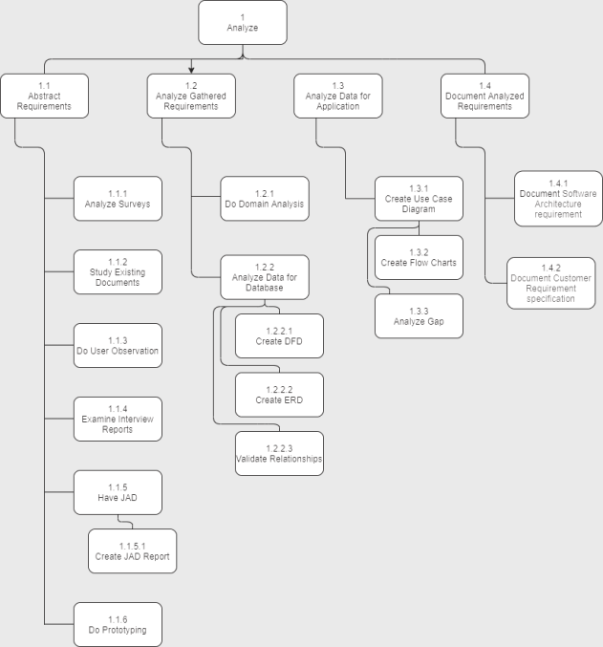

**WBS Diagram for Design Phase (Mostafa)**

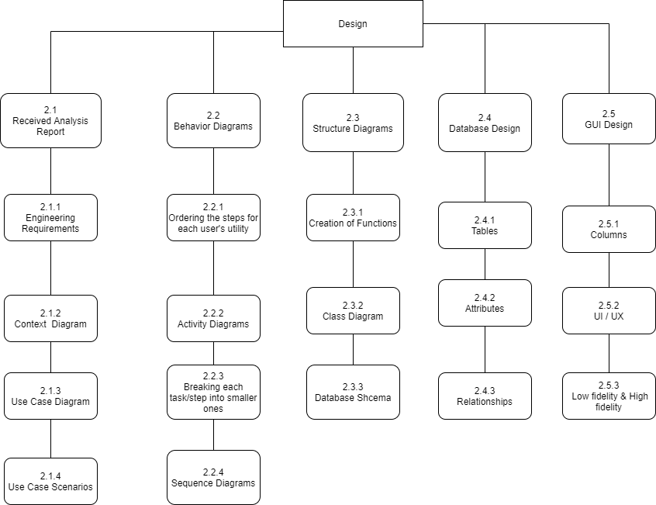

**REVISED WBS Diagram for Implementation Phase (Basel)**

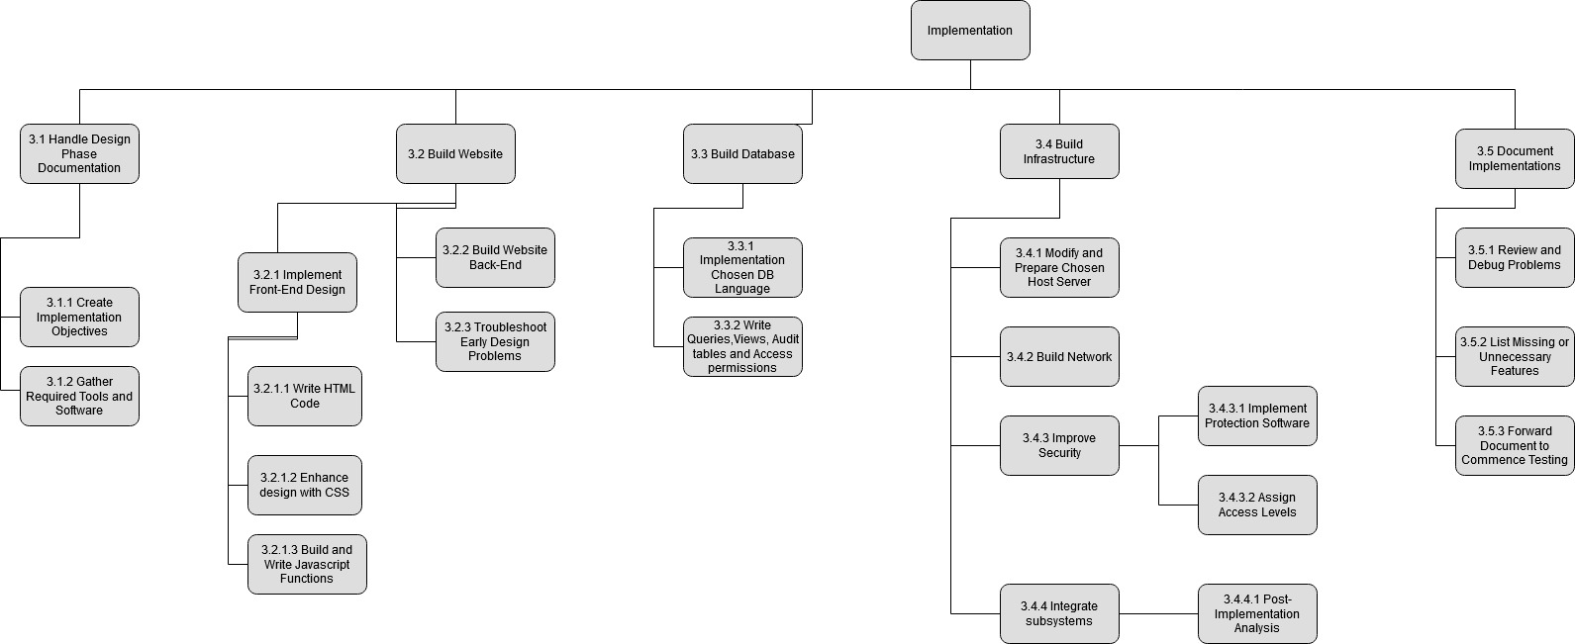

**WBS Diagram for Testing Phase (Mohamed)**

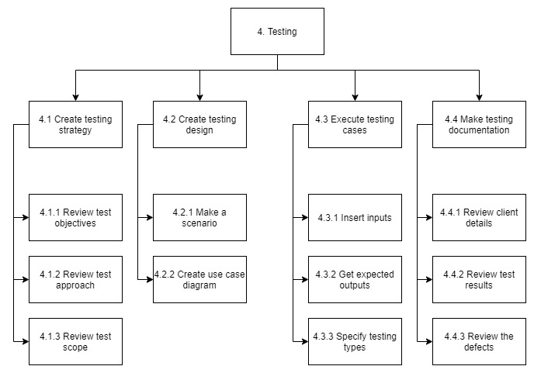

CINEMA MANAGEMENT SYSTEM PMP

CMS

11/6/2020

**SECTION 4. TECHNICAL PROCESS**

**4.1 METHODS, TOOLS AND TECHNIQUES**

**Methods:**

* **SPM:** “Prince2” method will be used in the project due to its ability to break the project down into phases which makes the project easy and flexible to adjust, each phase will be assigned to the appropriate team; however, the teams must be familiar with the prince2 method and a lot of effort must be put into documenting and logging at every stage.
* **SDM:** “Waterfall” method will fit the project needs where this method goes far with the simple classic method to a new advanced level which apply the team members to finish a step and go to the next as it clears from the method name “Waterfall” also the system will have a clear requirement before the coding phase and few changes will be needed while proceeding the project phases.

**TOOLS:**

* **Microsoft projects:** This tool will assist the team members in making schedules, relating resources to tasks, controlling the budget, tracking the project progress and analyzing the workloads.
* **Draw io:** This tool will assist the team members in the design phase where the diagrams will be needed.
* **NetBeans:** This tool will assist the team members in using “Java” as a programming language for the system software.
* **SQL:** This tool will assist the team members in creating a database.

**Techniques:**

Projects seems in the beginning complex and there are more to do so the Work Breakdown Structure (WBS) technique is solution to plan and organize the work in small parts.

**4.3** **PROJECT INFRASTRUCTURE**

The project will be hosted on Amazon AWS EC2 Web Hosting service. It will not require more than 2GB of RAM, 1 CPU Core, 20GB of Storage and Moderate Transfer speeds. The cost is to be negotiated directly with the seller, but the expected cost is $10k/mo. This server runs on the Linux operating system.

**SECTION 5. MANAGEMENT PROCESS**

**5.2 WORK PLANNING**

**5.2.2 SCHEDULE ALLOCATION**

**Ziad:**

**CPM**

| **Activity** | **Description** | **Predecessor** | **Duration (Days)** |
| --- | --- | --- | --- |
| **A** | Analyze Surveys | - | 7 |
| **B** | Study Existing Documents | - | 3 |
| **C** | Do User Observation | G | 6 |
| **D** | Examine Interview Reports | - | 3 |
| **E** | Have JAD | A | 1 |
| **F** | Create JAD Report | E | 2 |
| **G** | Do Prototyping | A, B | 5 |
| **H** | Do Domain Analysis | G | 3 |
| **I** | Analyze Data for Database | C | 2 |
| **J** | Create DFD | I | 1 |
| **K** | Create ERD | I | 2 |
| **L** | Validate Relationships | K | 2 |
| **M** | Create Use Case Diagram | K | 4 |
| **N** | Create Flow Chart | K | 3 |
| **O** | Analyze Gap | N | 2 |
| **P** | Document Software Architecture Requirements | N | 7 |
| **Q** | Document Customer Requirements Specifications | N | 3 |

The Critical Path: A, E, G, C, I, K, N, P

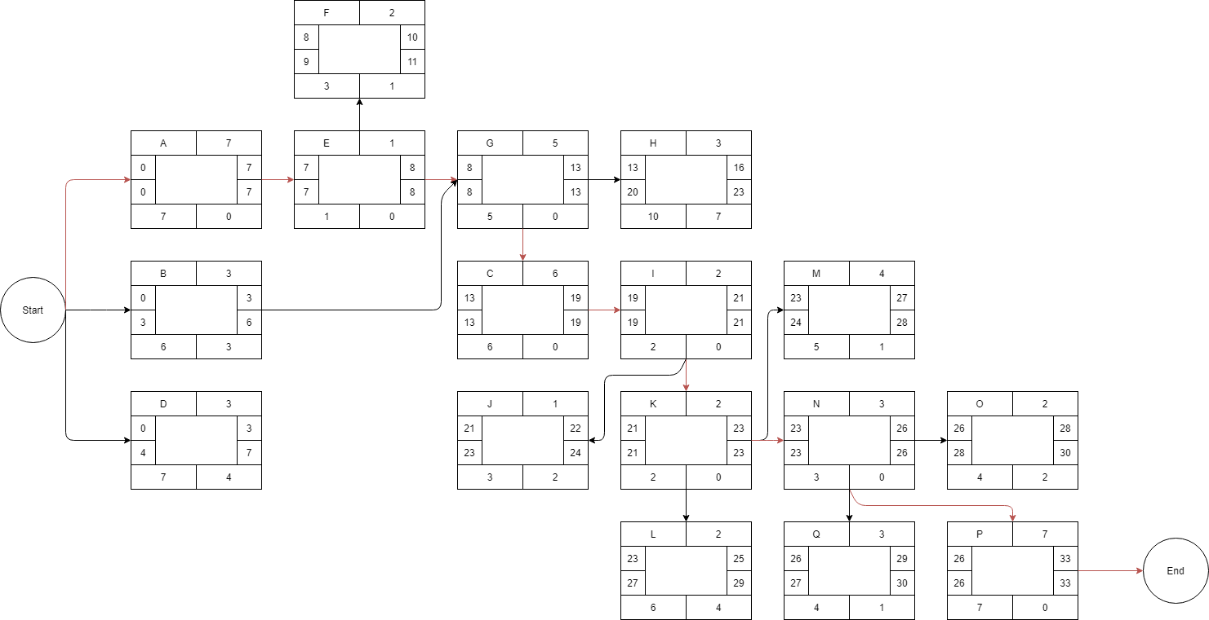

**Mostafa:**

| **Activity** | **Description** | **Predecessor** | **Duration (Days)** |
| --- | --- | --- | --- |
| **A** | Receive engineering requirements | - | 1 |
| **B** | Design context diagram | - | 1 |
| **C** | Design use-case diagram | A | 2 |
| **D** | Write scenarios | C | 2 |
| **E** | Order the steps of using the system | C, D | 1 |
| **F** | Design activity diagrams | E | 2 |
| **G** | Break tasks into smaller ones | E | 1 |
| **H** | Design sequence diagrams | G | 4 |
| **I** | Create functions | C | 2 |
| **J** | Design Class Diagram | I | 3 |
| **K** | Make database schema | J | 2 |
| **L** | Create tables in the database | K | 2 |
| **M** | Fill the attributes  With data | L, G | 2 |
| **N** | Assign relationships between tables | J | 2 |
| **O** | Make GUI columns | - | 3 |
| **P** | Design & make UI / UX | O, C | 5 |
| **Q** | Use high fidelity / low fidelity | P, M | 6 |

**Basel:**

**Precedence Table:**

| **Activity** | **Description** | **Predecessor** | **Duration (Days)** |
| --- | --- | --- | --- |
| **A** | Create Implementation Objectives | - | 3 |
| **B** | Gather Required Tools and Software | - | 1 |
| **C** | Write HTML Code | A | 4 |
| **D** | Enhance Design with CSS | C | 6 |
| **E** | Build and Write JavaScript Functions | D | 3 |
| **F** | Build Website Back-End | E | 7 |
| **G** | Troubleshoot Early Design Problems | F | 2 |
| **H** | Implement Chosen DB Language | B | 3 |
| **I** | Write Queries, Views, Audit Tables and Access Permissions | F, H, M | 3 |
| **J** | Modify and Prepare Host Server | - | 1 |
| **K** | Build Network | G, J | 3 |
| **L** | Implement Protection Software | K | 3 |
| **M** | Assign Access Levels | L | 1 |
| **N** | Post Implementation Analysis | M, K | 3 |
| **O** | Review and Debug Problems | N | 3 |
| **P** | List Missing or Unnecessary Features | O | 2 |
| **Q** | Forward Document to Commence Testing | P | 1 |

Critical Path 1: A, C, D, E, F, G, K, L, M. N, O, P. Q

Critical Path 2: A, C, D, E, F, I, M, N, O, P, Q

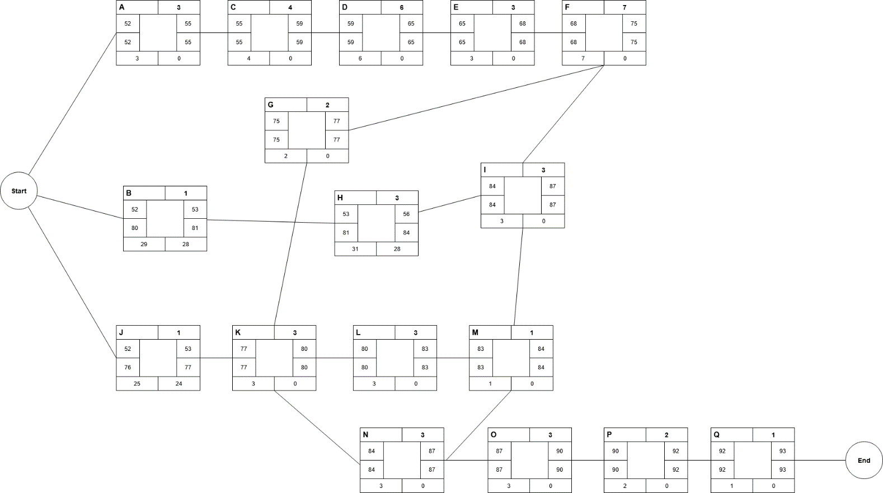

**Mohamed:**



Critical Path 1: A, B, C, I

Critical Path 2: A, B, D, A

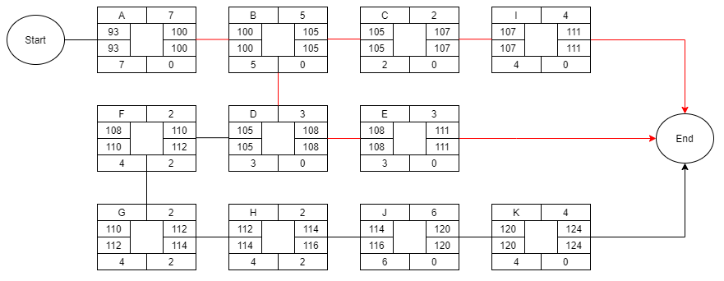

**5.4 Risk Management**

**Ziad:**

**Risk Assessments:**

| **Risk Type** | **Risk** | **Risk Description** | **Risk Exposure** |
| --- | --- | --- | --- |
| **Generic** | Communication | Bad team communication can lead to waste of resources and critical failures which may lead to project delay | $27K * .03 = $810 |
| **Generic** | Funding | The client may fail to fund or the project may need more funding than the estimated amount | $135K * .10 = $13.5K |
| **Specific** | Requirements | Requirements may not be very clear or specific | $15K * .07 =  $1.05K |
| **Specific** | Prototype | Users or Developers may get too attached to the prototype which may cause development issues or users unsatisfaction | $35K * .05 = $1.75K |
| **Specific** | Survey | Survey participants may not be present in the time of start | $10K * .2 = $2K |

**Risk Planning:**

**Requirements Risk:**

Probability of loss 0.07 BEFORE Resolution

Loss $15,000

Exposure to unclear requirements 0.07 x $15,000 = $1,050

Now we provide a method of reducing the possibility of working on unclear requirements by making a list of questions to be asked to the client and ask him for a meeting in fixed time interval to review the work. This reduces the risk to 3%. The impact will be reduced to $7,500 as there will be a communication with the client regarding project updates. Anyways the cost of the reduction is $500 as a developer will have to meet with the client

Probability of 0.03 AFTER Resolution

Loss $7,500

Exposure 0.03 x $7,500 = $225

Cost of Risk Reduction $500

Risk Reduction Leverage = (1,050 – 225) / 500 = 1.65

**Contingency Plan:**

If the client already provided unclear or unspecific requirements then any work concerning this requirement shall be paused until the client provides further clarification regarding it to avoid any waste of resources.

**Survey Risk:**

Probability of loss 0.2 BEFORE Resolution

Loss $10,000

Exposure to unclear requirements 0.2 x $10,000 = $2,000

Now we provide a method of reducing the possibility of a survey participant of not showing up by making a group survey instead of individual survey. This reduces the risk to 7%. The impact will be reduced to $5,000 as if a few of participants won’t show up it won’t make such a difference as the others will cover and it won’t delay the survey stage. Anyways the cost of the reduction is $1250 as a developer will have to meet with the client.

Probability of 0.03 AFTER Resolution

Loss $5,000

Exposure 0.07 x $5,000 = $350

Cost of Risk Reduction $1250

Risk Reduction Leverage = (2,000 – 350) / 1250 = 1.32

**Contingency Plan:**

If present survey data is insufficient due to survey participants’ absence and there was still enough time for the survey then try to recruit others as soon as possible. But if there is a catastrophic event that prevent participants to come then try to make the survey online.

**Risk Planning: [PERT]**

| **Activity** | **Optimistic** | **Most Likely** | **Pessimistic** | **Expected Time** | **Standard Deviation** | **Comment** |
| --- | --- | --- | --- | --- | --- | --- |
| **A (Analyze Surveys)** | 3 | 7 | 10 | 6.83 | 1.16 | **Optimistic**: If all participants came on time and the process was smooth  **Pessimistic**: If any alerting events happened like global pandemic or environmental disasters or participants didn’t show up for any reason |
| **Q (Document Customer Requirements Specifications)** | 2 | 5 | 7 | 4.83 | 0.83 | **Optimistic**: If all the reports and required work was ready for documenting.  **Pessimistic**: If some of the reports wasn’t ready yet or any delay happened to any of the analyze phases |

**Mostafa:**

**Risk Assessments:**

| Risk Type | Risk | Risk Description | Risk Exposure |
| --- | --- | --- | --- |
| Generic | Communication & cooperating | Unproper team cooperation can lead to waste of time & resources. | $10K * 0.02 = $200 |
| Generic | System Errors | In case the systems or networks crashed or had any technical errors, this shall lead to critical issues. | $30K * 0.05 = 1500$ |
| Specific | Changes in Analysis Report | If the client made major changes in the requirements, it will eventually force the design team to re-design most of the diagrams which are very important for the whole design process. | $15K * 0.3 = 4500$ |
| Specific | System mechanism  misbehavior | If the developers made any mistakes in the behavior diagrams or the database design process, it will affect the implementation process leading to huge risks like system misbehavior while using it. | $30K * 0.07 = 2100$ |
| Specific | User Interface Design | UI/UX developers may not apply all the client’s requests regarding the system’s user interface because the impossibility of them. | $8K * 0.2 = 1600$ |

**Risk Planning:**

-Changes in Analysis Report Risk:

Probability of loss 0.3 BEFORE Resolution

Loss 30,000$

Exposure to Analysis Report changes: 0.3 x 15,000$ = 4500$

-The best possible method to reduce the event of this risk is to ensure that the client is fully satisfied with his requirements and the analysis report is 100% ready to be delivered to the design team , that is done by assigning a Business -IT expert to reduce the gap between the client and developers. . This reduces the risk to 6%. The impact will be reduced to $10,000 as there will be a better communication with the client regarding project requirements.

Probability of 0.06 AFTER Resolution

Loss $10,000

Exposure 0.06 x $10,000 = $600

Cost of Risk Reduction $3,500

Risk Reduction Leverage = (4500-600)/3500 / = 1.11

-The solution is worthy

**-System misbehavior Risk:**

Probability of loss 0.07 BEFORE Resolution

Loss $30,000

Exposure to System misbehavior: 0.07 x $30,000 = $2,100

-The most effective way to avoid this problem is to design the behavior diagrams very carefully and work together with the implementation team to check every step and every process through the design of the database and its schema to make sure it will be well-operated in the system avoiding any functional misbehavior. It will reduce the risk possibility to 3%.

Probability of 0.03 AFTER Resolution

Loss $12,000

Exposure 0.03 x $12,000 = $360

Cost of Risk Reduction $2000

Risk Reduction Leverage = (2,100 – 360) / 2000 = 1.32 = 0.87

-The solution is not worthy at this case.

Analysis Risk:

-If the client made too many changes in the requirements, the design team must stop their work until everything is settled.

System Risk:

-The testing team must co-work with the design developers and implementation to test every case step by step and make sure everything is well operating.

**Risk Planning:**

| **Activity** | **Optimistic** | **Most Likely** | **Pessimistic** | **Expected Time** | **Standard Deviation** | **Comment** |
| --- | --- | --- | --- | --- | --- | --- |
| **A (Analysis Report)** | 10 | 14 | 20 | 14.3 | 1.667 |  |
| **I (System design)** | 7 | 10 | 12 | 9.83 | 0.83 |  |

**Basel:**

**Risk Assessments:**

| **Risk Type** | **Risk** | **Risk Description** | **Risk Exposure** |
| --- | --- | --- | --- |
| **Generic** | Servers | Purchased servers may not be able to handle the sustained heavy load required to run the system | $15K * .1 = $1500 |
| **Generic** | Data Loss | Storage server malfunctions may cause the loss of most of project data. This would cost precious development time. | $150K * .3 = $45K |
| **Specific** | Language Incompatibility | Selected DB or Back-End languages may not satisfy the requirements set by project lead. | $21K * .18 =  $3780 |
| **Specific** | Security Incompetence | Testing phase might expose several undiscovered backdoors or vulnerabilities in the system, requiring further improvements | $310K * .2 = $62K |
| **Specific** | Servers | Purchased server may not be able to handle sustained heavy load, requiring data migration. | $18K * .1 = $1.8K |

**Risk Planning:**

**Language Incompatibility** **Risk**:

Probability of loss 0.18 BEFORE Resolution

Loss $21000

Exposure to Language Incompatibility 0.18 x $21,000 = $3780

By researching commonly used languages and creating a checklist of features, applying analysis phase prototyping/survey results then choosing ones that better satisfy project requirements, this reduces the risk to 5%. However, the cost of introducing the loss reduction is $750.

Probability of loss 0.05 AFTER Resolution

Loss $21000

Exposure 0.05 x $21000 = $1050

Cost of Risk Reduction: $750

Risk Reduction Leverage (RRL) = (3780 – 1050) / 750 = 3.64

**This is highly recommended.**

**Contingency Plan:**If this event occurs, trained staff will proceed to re-implement missing features using different languages that are compatible with project requirements. Staff must be experienced in multiple languages in their field of work.

**Security Incompetence Risk**:

Probability of loss 0.20 BEFORE Resolution

Loss $310000

Exposure to Security Incompetence 0.2 x $310000 = $62000

By filling the servers with redundant data and hiring penetration testers to make sure implemented security features have no loopholes or vulnerabilities, this reduces the risk to 3%. However, the cost of introducing the loss reduction is $6000.

Probability of loss 0.03 AFTER Resolution

Loss $310000

Exposure 0.03 x $310000 = $9300

Cost of Risk Reduction $6000

Risk Reduction Leverage (RRL) = (62000 – 9300) / 6000 = 8.73

**This is very highly recommended and should be considered a top priority.**

**Contingency Plan:**

If security vulnerabilities are found after the implementation of Risk Reduction techniques, vulnerable servers will be taken offline until sad vulnerabilities are patched. System users will be notified of said procedure and servers must be monitored for unauthorized access at all times. In the case of data loss or theft, affected users are to be notified immediately and appropriate steps are to be taken.

**Risk Planning: [PERT]**

| **Activity** | **Optimistic** | **Most Likely** | **Pessimistic** | **Expected Time** | **Standard Deviation** | **Comment** |
| --- | --- | --- | --- | --- | --- | --- |
| **L (Implement Protection Software)** | 2 | 3 | 5 | 3.16 | 0.5 | **Optimistic**: If no problems occur during protection software implementation.  **Pessimistic**: If several problems and incompatibility issues arise during software implementation. |
| **N (Post-Implementation Analysis)** | 2 | 4 | 7 | 4.16 | 0.83 | **Optimistic**: If no issues are found with overall work done in phase.  **Pessimistic**: If problems arise in multiple task implementations and long modifications are required. |

**Mohamed:**

| Risk Type | Risk | Risk Description | Risk Exposure |
| --- | --- | --- | --- |
| Generic | Scope | Failure to assign specific tasks to team members may cause unnecessary additional tasks to be performed, which may harm the deadline. | $30K * 0.15 = $4.5K |
| Generic | Cost | Failure to set an adequate budget for the project may cause it to fail. | $73K * 0.07 = $5.1K |
| Generic | Time | Not specifying sufficient time for tasks and additional time for emergency circumstances may hinder the progress of the project. | $120K * 0.10 = $12K |
| Specific | Objectives | The lack of clarity of the objectives well to establish a specific approach to achieving them can expose the project to great risk. | $50K * 0.20 = $10K |
| Specific | Client | Failure to understand the client well and clearly understand his requirements can cause delays in progress and financial losses. | $65K * 0.40 = $26K |

**Risk planning:**

**Cost Risk:**

Probability of loss 0.07 before resolution

Loss $73K

Exposure 0.07 * $73K = $5.1K

To reduce the possibility of cost the budget must be well planned and specialized companies must be contracted to bear the cost of some of the hardware and software requirements, and a reserve money must be put in place to bear any sudden deficit. This reduces the risk to 2%. The impact will be reduced to $43K. So, the cost of the reduction is $5K.

Probability of loss 0.02 after resolution

Loss $43K

Exposure 0.02 x $43K = $0.86K

Cost of Risk Reduction $5000K

Risk Reduction Leverage = (5.1 – 0.86) / 5 = 0.848

**Contingency Plan:**   
If there is a deficit in the cost of the project, it is necessary to search for the tasks that have priority in the project and are funded, and to search for supplies that are less expensive than they were supposed to bring.

**Client Risk:**

Probability of loss 0.40 before resolution

Loss $65K

Exposure 0.40 * $65K = $26K

To reduce the possibility of the client not understanding well and realizing his requirements, more than one interview with the client must be specified in a suitable place to understand his requests and record them well. Communication with the client must always be done to take his opinion with each progressive step in the project and to confirm his satisfaction with this implementation. This reduces the risk to 15%. The impact will be reduced to $20K. So, the cost of the reduction is $10K.

Probability of loss 0.15 after resolution

Loss $20K

Exposure 0.15 x $20K = $3K

Cost of Risk Reduction $10K

Risk Reduction Leverage = (26 – 3) / 10 = 2.3

**Contingency Plan:**

If it is discovered that there is a misconception of a request for the client, must stop working on the project until the client meets, re-questions his requests, and tries to negotiate to reduce losses from what has been accomplished and he is not satisfied with it.

[PERT]

| **Activity** | **Optimistic** | **Most Likely** | **Pessimistic** | **Expected Time** | **Standard Deviation** | **Comment** |
| --- | --- | --- | --- | --- | --- | --- |
| **A (Review test objectives)** | 5 | 8 | 12 | 8.17 | 1.17 | **Optimistic**: If all objectives were clear and specified well.  **Pessimistic**: If there is lack of clarity of the objectives well. |
| **J (Review test results)** | 4 | 6 | 10 | 6.33 | 1 | **Optimistic**: If all test results are well organized and all ready  **Pessimistic**: If the test results are poorly arranged, random, and have some deficiencies. |